National Workshop on Prevention and Control of Diarrheal Disease

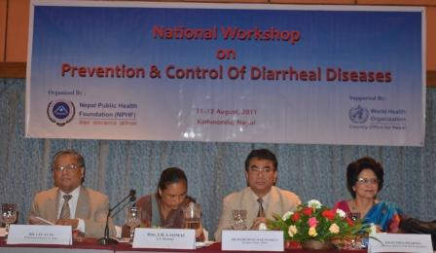

Description:
Diarrheal diseases, despite being, to a large extent, manageable in terms of prevention and treatment, Nepal still faces endemics and outbreaks time and again in several districts. The problems of diarrheal diseases are largely attributable to inadequate safe drinking water supply, poor sanitation and sub-optimal living conditions. Nepal Public Health Foundation with support of WHO Country Office organized a two-day workshop on 11-12th August 2011 with a support of WHO Country office, Nepal regarding the prevention and control of Diarrhoeal diseases. The main objective of the workshop was to bring together various civil societies and academies from the health sector and the government in order to come up with a substantial solution to deal with Diarrhoeal diseases in Nepal and concentrate efforts on preventing it.
Display Order: 10
Status : Active

National Workshop on Non- Communicable Disease
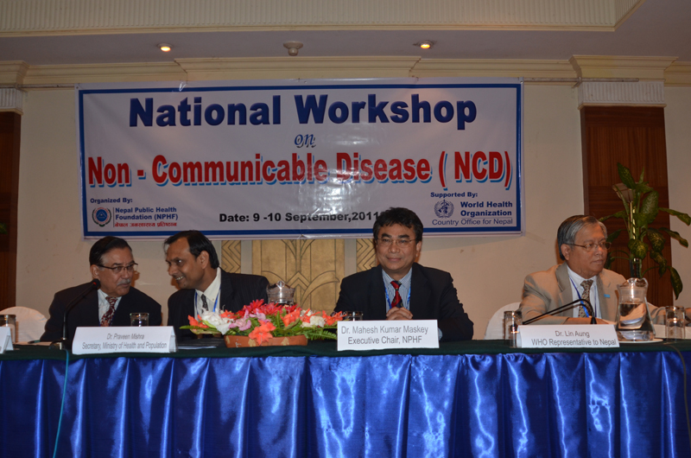

Description:
As a follow up of Regional Civil Society Meeting on NCD, NPHF organized a National Workshop on NCD on 9-10th September, 2011 with the objective to review and discuss the selected global and regional NCD related policy documents, analyze and amend the drafted national policy on NCD. The planned meeting will also explore the possibility of establishment of National NCD net comprising with various partner stakeholders working in the field of NCD.
The workshop came up with amendments in the draft NCD policy after analyzing it and recommended to the Ministry of Health. It also discussed on NCD related agenda and drafted a summary including issues to be raised in 66th UN General Meeting which was handed over to Nepal delegation before leaving for the Meeting. Similarly, an ad hoc committee was also formed that was supposed to draft a modality on setting up the NCD net and make it functional and sustainable.
Display Order: 8
Status: Active

